# 1. Project Name:

**PO5_LED STRING ANIMATION**

# 2. Table History:

|  |  |  |  |
| --- | --- | --- | --- |
| **Author** | **Version** | **Date** | **Change Description** |
| Walid Adel | 1.0 | 27/2/2020 | Initial Creation |
| Walid Adel | 1.1 | 28/2/2020 | Added Timer Driver Module API’s in MCAL |
| Walid Adel | 1.2 | 3/1/2020 | * Added 1- Input Output Signals   2-Software Features   * Modified Software Context Diagram * Added Req. ID and Req. Coverage to Each of API table |
| Walid Adel | 1.3 | 3/2/2020 | Modified the Software Feature Diagram and some Req. Coverage for The API’s |
| Walid Adel | 1.4 | 3/7/2020 | Covered All the Review Points that were Opened in the Review Document and also the Comments Pointed out at the last Review meeting held at 3/6/2020 |

# 3. Document Status:

|  |  |  |  |
| --- | --- | --- | --- |
| **Author** | **Version** | **Date** | **Status** |
| Walid Adel | 1.4 | 3/7/2020 | Released |

# 4. Reference Documents:

|  |  |  |  |
| --- | --- | --- | --- |
| **Reference No.** | **Document Name** | **Version** | **Status** |
| 1 | Req_ PO5_LED STRING ANIMATION_CYRS.doc | 2.2 | Released |
| 2 | Req_ PO5_LED STRING ANIMATION_HSI.doc | 1.5 | Released |

# 4. Table of Content:

Contents

1. Project Name: 1

2. Table History: 1

3. Document Status: 1

4. Reference Documents: 1

4. Table of Content: 2

5. Software Context Diagram: 3

6. Input Output Signals: 3

6.2 Input Signals 3

6.2 Output Signals 3

7. Software Features: 4

8. Static Architecture: 4

8.1 Layered Architecture Diagram: 4

8.2 Layers Description: 5

9. Component API’s: 6

9.1 APPLICATION Layer Components: 6

9.1.1 MODE MODULE 6

9.1.2 TI_LEFT MODULE 6

9.1.3 TI_RIGHT MODULE 7

9.1.4 TAIL MODULE 7

9.1.5 BACK LIGHTING CONTROLLER MODULE 7

9.2 ECUAL Components: 8

9.2.1 LED DRIVER 8

9.2.2 SWITCH DRIVER 8

9.3 MCAL Components: 8

9.3.1 GPIO DRIVER 8

9.3.2 TIMER DRIVER 9

# 5. Software Context Diagram:

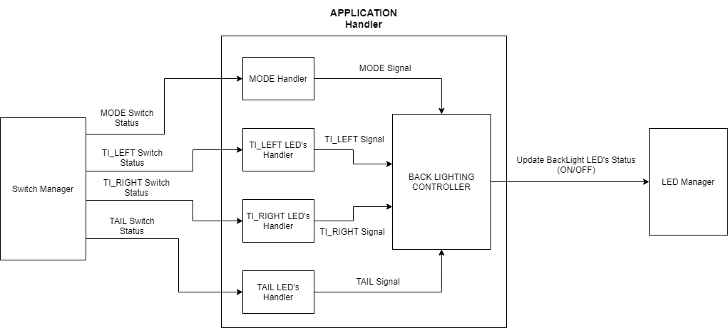

# 6. Input Output Signals:

## 6.2 Input Signals

|  |  |  |  |
| --- | --- | --- | --- |
| **Signal Name** | **Signal Type** | **Unit** | **Range** |
| Signal_MODESwitch | Input | N/A | MODE_1 = 1, MODE_2 = 0 |
| Signal_TI_LEFTSwitch | Input | N/A | ON = 1, OFF = 0 |
| Signal_TI_RIGHTSwitch | Input | N/A | ON = 1, OFF = 0 |
| Signal_TAILSwitch | Input | N/A | ON = 1, OFF = 0 |

## 6.2 Output Signals

|  |  |  |  |
| --- | --- | --- | --- |
| **Signal Name** | **Signal Type** | **Unit** | **Range** |
| Signal_UpdateLEDStatus | Output | N/A | ON = 1, OFF = 0 |

# 7. Software Features:

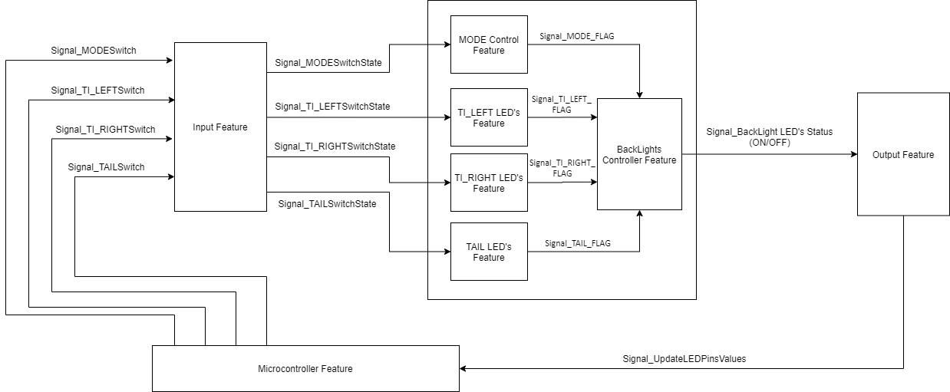

# 8. Static Architecture:

## 8.1 Layered Architecture Diagram:

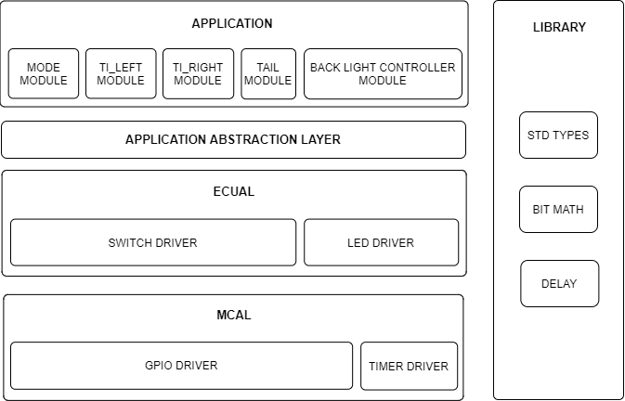

## 8.2 Layers Description:

1-

|  |  |  |
| --- | --- | --- |
| **Layer** | **Module** | **Module Description** |
| APPLICATION | MODE MODULE | Responsible for continuously reading the MODE switch status |
| TI_LEFT MODULE | Responsible for continuously reading the TI LEFT switch status |
| TI_RIGHT MODULE | Responsible for continuously reading the TI RIGHT switch status |
| TAIL MODULE | Responsible for continuously reading the TAIL switch status |
| BACK LIGHTING MODULE | Responsible for analyzing all switches status and based on those inputs it will activate the TI_LEDs and TAIL LEDs according to either MODE_1 or MODE_2 |

2-

|  |  |  |
| --- | --- | --- |
| **Layer** | **Module** | **Module Description** |
| APPLICATION ABSTRACTION LAYER | N/A | Responsible For Handling all The Internal Communications between All Modules in The APPLICATION Layer |

3-

|  |  |  |
| --- | --- | --- |
| **Layer** | **Module** | **Module Description** |
| ECUAL | SWITCH DRIVER | Responsible for Polling all the switches status flags in the system |
| LED DRIVER | Responsible for Updating all the LEDs state in the system |

4-

|  |  |  |
| --- | --- | --- |
| **Layer** | **Module** | **Module Description** |
| LIBRARY | STD_TYPES | Header file that contains all variable types that will be used in the system |
| BIT_MATH | Header file that contains all common macros that are needed in the system |
| DELAY MODULE | This Module Contains a Delay Function that is used by the timer driver to execute a delay with a specified value |

5-

|  |  |  |
| --- | --- | --- |
| **Layer** | **Module** | **Module Description** |
| MCAL | GPIO DRIVER | Responsible for:   * Configuring the pins mode. * Writing/Reading from the pins. |
| TIMER DRIVER | Responsible for :   * Configuring the timer’s modes of the system. * Starting the timer’s |

# 9. Component API’s:

## 9.1 APPLICATION Layer Components:

### 9.1.1 MODE MODULE

1-

|  |  |
| --- | --- |
| **Req. ID** | Req_PO5_LSAN_GDD_001_V01 |
| **Req. Coverage** | Req_PO5_LSAN_SRS_002_V02 , Req_PO5_LSAN_SRS_022_V02 |
| **API Prototype** | Mode_u8ERROR_STATUSGetStatus(u8* Switch_Status ) |
| **Description** | This API is responsible for getting the MODE switch state |
| **Input Parameters** | u8* Switch_Status {Pointer to a variable at which the status of the switch will be stored, The Value Will be either PRESSED = 1 or RELEASED =0} |
| **Output Parameters** | u8 ERROR_STATUS {OK = 1, NOK = 0} |

### 9.1.2 TI_LEFT MODULE

1-

|  |  |
| --- | --- |
| **Req. ID** | Req_PO5_LSAN_GDD_002_V01 |
| **Req. Coverage** | Req_PO5_LSAN_SRS_020_V01 , Req_PO5_LSAN_SRS_021_V01 |
| **API Prototype** | TiLeft_u8ERROR_STATUSGetStatus(u8* Switch_Status ) |
| **Description** | This API is responsible for getting the TI_LEFT switch state |
| **Input Parameters** | u8* Switch_Status {Pointer to a variable at which the status of the switch will be stored, The Value Will be either PRESSED = 1 or RELEASED =0} |
| **Output Parameters** | u8 ERROR_STATUS {OK = 1, NOK = 0} |

### 9.1.3 TI_RIGHT MODULE

1-

|  |  |
| --- | --- |
| **Req. ID** | Req_PO5_LSAN_GDD_003_V01 |
| **Req. Coverage** | Req_PO5_LSAN_SRS_015_V03 , Req_PO5_LSAN_SRS_019_V01 |
| **API Prototype** | TiRight_u8ERROR_STATUSGetStatus(u8* Switch_Status ) |
| **Description** | This API is responsible for getting the TI_RIGHT switch state |
| **Input Parameters** | u8* Switch_Status {Pointer to a variable at which the status of the switch will be stored, The Value Will be either PRESSED = 1 or RELEASED =0} |
| **Output Parameters** | u8 ERROR_STATUS {OK = 1, NOK = 0} |

### 9.1.4 TAIL MODULE

1-

|  |  |
| --- | --- |
| **Req. ID** | Req_PO5_LSAN_GDD_004_V01 |
| **Req. Coverage** | Req_PO5_LSAN_SRS_012_V02 , Req_PO5_LSAN_SRS_023_V01 |
| **API Prototype** | Tail_u8ERROR_STATUSGetStatus(u8* Switch_Status ) |
| **Description** | This API is responsible for getting the TAIL switch state |
| **Input Parameters** | u8* Switch_Status {Pointer to a variable at which the status of the switch will be stored, The Value Will be either PRESSED = 1 or RELEASED =0} |
| **Output Parameters** | u8 ERROR_STATUS {OK = 1, NOK = 0} |

### 9.1.5 BACK LIGHTING CONTROLLER MODULE

1-

|  |  |
| --- | --- |
| **Req. ID** | Req_PO5_LSAN_GDD_005_V01 |
| **Req. Coverage** | Req_PO5_LSAN_SRS_003_V02 , Req_PO5_LSAN_SRS_011_V02 , Req_PO5_LSAN_SRS_013_V02 , Req_PO5_LSAN_SRS_014_V03 , Req_PO5_LSAN_SRS_016_V03 , Req_PO5_LSAN_SRS_017_V02 ,  Req_PO5_LSAN_SRS_018_V01 |
| **API Prototype** | void BackLightingController(void) |
| **Description** | This API is responsible for Starting a runnable that integrate the whole Back Lighting System by:   * Analyzing the input signals from other modules to choose which mode (MODE_1, MODE_2) at start-up will execute * Updating the Back Lights LED’s status |
| **Input Parameters** | Void |
| **Output Parameters** | Void |

## 9.2 ECUAL Components:

### 9.2.1 LED DRIVER

1-

|  |  |
| --- | --- |
| **Req. ID** | Req_PO5_LSAN_GDD_006_V01 |
| **Req. Coverage** | Req_PO5_LSAN_SRS_003_V02 , Req_PO5_LSAN_SRS_011_V02 , Req_PO5_LSAN_SRS_013_V02 , Req_PO5_LSAN_SRS_014_V02 , Req_PO5_LSAN_SRS_016_V02 , Req_PO5_LSAN_SRS_017_V02 ,  Req_PO5_LSAN_SRS_018_V01 |
| **API Prototype** | LED_ u8ERROR_STATUS UpdateStatus (u8 LED_Num , u8 status) |
| **Description** | This API is responsible for Setting the LED status to be ON/OFF |
| **Input Parameters** | 1. u8 LED_Num {LED_1 = 0, LED_2 = 1, etc.} 2. u8 status {ON = 1, OFF = 0} |
| **Output Parameters** | 1. u8 ERROR_STATUS {OK = 1, NOK = 0} |

### 9.2.2 SWITCH DRIVER

1-

|  |  |
| --- | --- |
| **Req. ID** | Req_PO5_LSAN_GDD_007_V01 |
| **Req. Coverage** | Req_PO5_LSAN_SRS_002_V02 , Req_PO5_LSAN_SRS_012_V02 , Req_PO5_LSAN_SRS_015_V02 , Req_PO5_LSAN_SRS_019_V02 , Req_PO5_LSAN_SRS_020_V02 , Req_PO5_LSAN_SRS_021_V02 , Req_PO5_LSAN_SRS_023_V02 |
| **API Prototype** | SWITCH_ u8ERROR_STATUSGetStatus (u8 Switch_Num ,u8* Status) |
| **Description** | This API is responsible Reading the status of the switch |
| **Input Parameters** | 1. u8 Switch_Num {SWITCH_1 = 0, SWITCh_1 = 1, etc.} 2. u8 *Status {Pointer to a variable at which the status of the switch will be stored, The Value Will be either PRESSED = 1 or RELEASED =0} |
| **Output Parameters** | 1. u8 ERROR_STATUS {OK = 1, NOK = 0} |

## 9.3 MCAL Components:

### 9.3.1 GPIO DRIVER

1-

|  |  |
| --- | --- |
| **Req. ID** | Req_PO5_LSAN_GDD_008_V01 |
| **Req. Coverage** | Req_PO5_LSAN_HSI_001_V01 , Req_PO5_LSAN_SRS_024_V02 |
| **API Prototype** | GPIO_ u8ERROR_STATUSInit(void) |
| **Description** | This API is responsible for initializing the Microcontroller GPIO Pins Direction by Writing on the DDRx Registers |
| **Input Parameters** | Void |
| **Output Parameters** | u8 ERROR_STATUS {OK = 1, NOK = 0} |

2-

|  |  |
| --- | --- |
| **Req. ID** | Req_PO5_LSAN_GDD_009_V01 |
| **Req. Coverage** | N/A |
| **API Prototype** | GPIO_ u8ERROR_STATUS WritePin(u8 Port, u8 Pin, u8 Value) |
| **Description** | This API is responsible for writing on A specified GPIO pin by Writing on the PORTx register Using the Value Entered |
| **Input Parameters** | 1. u8 Port {“A”, “B”, “C”, “D”} 2. u8 Pin {PIN_0 = 0, PIN_1 = 1, PIN_2 = 2, etc.} 3. u8 Value {LOW = 0, HIGH=1} |
| **Output Parameters** | 1. u8 ERROR_STATUS {OK = 1, NOK = 0} |

3-

|  |  |
| --- | --- |
| **Req. ID** | Req_PO5_LSAN_GDD_010_V01 |
| **Req. Coverage** | N/A |
| **API Prototype** | GPIO_ u8ERROR_STATUSReadPin(u8 Port, u8 Pin, u8 *Value) |
| **Description** | This API is responsible for writing on a specified GPIO pin.   1. Reading From the PORTx register |
| **Input Parameters** | 1. u8 Port {“A”, “B”, “C”, “D”, “E”, “F”} 2. u8 Pin {PIN_0 = 0, PIN_1 = 1, PIN_2 = 2, etc.} 3. u8* Value {Ptr to hold the Value Read From The Pin, The Value Will be either HIGH = 1 or LOW =0} |
| **Output Parameters** | 1. u8 ERROR_STATUS {OK = 1, NOK = 0} |

### 9.3.2 TIMER DRIVER

1-

|  |  |
| --- | --- |
| **Req. ID** | Req_PO5_LSAN_GDD_011_V01 |
| **Req. Coverage** | N/A |
| **API Prototype** | TIMER_ u8ERROR_STATUSInit(void) |
| **Description** | This Api is responsible for initializing a specified timer by:   1. Configuring the timer mode (PWM, Overflow, CTC) 2. Setting the pre scalar 3. Setting the preload value |
| **Input Parameters** | Void |
| **Output Parameters** | u8 ERROR_STATUS {OK = 1, NOK = 0} |

2-

|  |  |
| --- | --- |
| **Req. ID** | Req_PO5_LSAN_GDD_012_V01 |
| **Req. Coverage** | N/A |
| **API Prototype** | TIMER_ u8ERROR_STATUSStart(void) |
| **Description** | This Api is responsible for starting the timer |
| **Input Parameters** | Void |
| **Output Parameters** | u8 ERROR_STATUS {OK = 1, NOK = 0} |